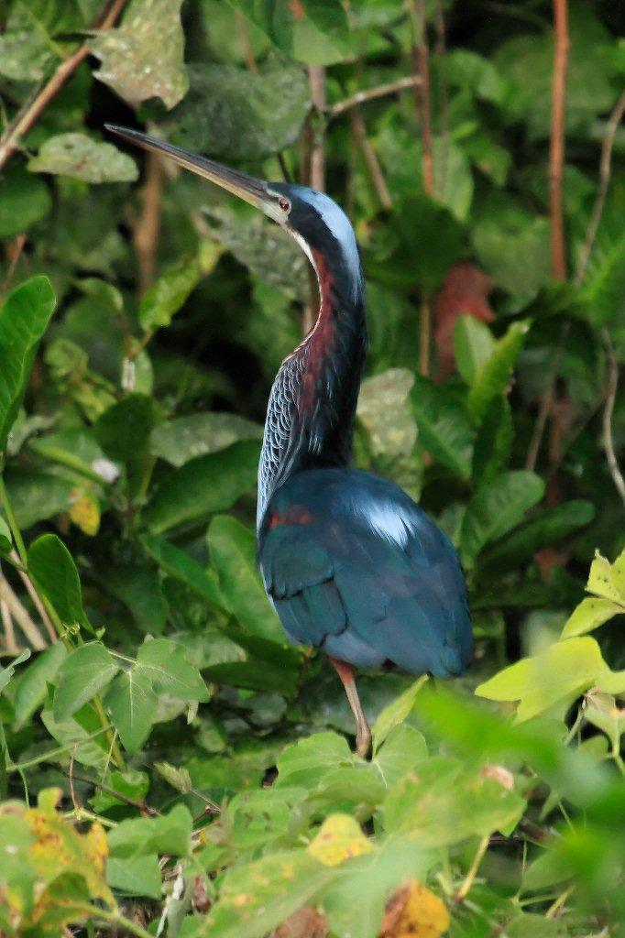
June 26th to July 11th 2010
The Atlantic Rainforest,
Pantanal and Chapada Dos Guimarães
BRAZIL
In Sept ‘09 my friend George and his wife Jen, who live in Seattle, were in the throes of organising a birding trip to the Pantanal in Brazil. The guide they’d engaged asked them to make the party size a minimum of four. They had three and wondered if I was interested in being the fourth.
Hmmm. Was I interested? Err, yes! We plumped for the two weeks 26th June to the 11th of July 2010. George, Jen and I settled on spending the first week in the Atlantic Rainforest. In the second week, we were to rendezvous with their friend Bryce and spend four and a half days in the Pantanal – the world’s biggest freshwater wetland - before finishing the trip with a day and a half in the dry savannah habitats of the Chapada dos Guimarães. A trip of a lifetime, with the chance of seeing somewhere in the region of 400-500 species of birds!

The Atlantic Rainforest
I suspect when most people think of rainforest, they immediately think of the Amazon. However, we were doing something a little unconventional - visiting Brazil to watch birds but not visiting the Amazon. The Atlantic Rainforest is one of the most biodiverse habitats in the world. Unfortunately, it has been decimated by development for agriculture and housing, with only about 9% of the original forest still standing. We were visiting a fabulous project called Reserva Ecologia Guapi Assu (REGUA). Situated about 80km north-east of Rio de Janeiro, it’s run by an Englishman called Nicholas Locke and his Brazilian wife Raquel. Formerly a cattle farm, they have restored and replanted great swathes of forest and created a superb wetland.
We arrived full of anticipation but were knocked out by how luxurious the Lodge was. Marbled bathrooms, spacious and spotlessly clean rooms, and the view from George and Jen’s balcony was to die for.
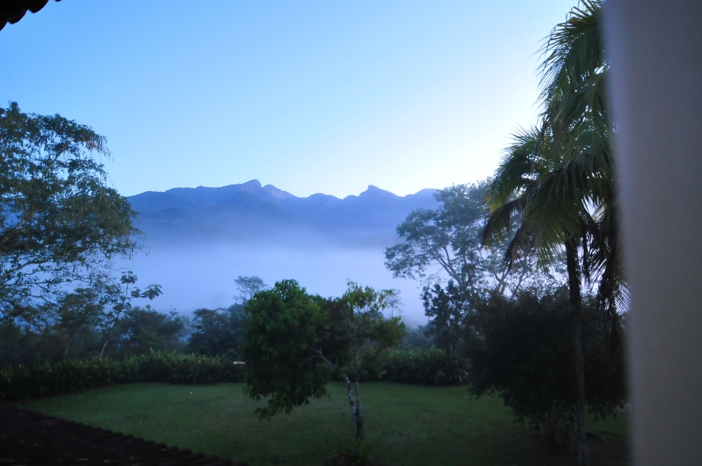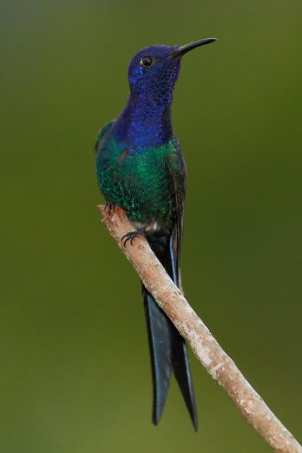
George and Jen’s balcony view and a regular garden visitor Swallow-tailed Hummingbird

Our guide for the week was Adilei, one of the reserve’s Forest Guardians. A former hunter, he grew up locally and is now a passionate birder and photographer - still hunting birds but no longer killing them. A superb mimic and a thoroughly lovely guy, we were in great hands. It’s hard to understate just how good a guide Adilei was. From our first few minutes with him, until the day we left, he made it his mission to make our stay a memorable one and his ability to track down the wildlife was incredible. Despite a very limited grasp of English on his part and an even looser grip on Portuguese by us, we had a great laugh together.
The reserve is crisscrossed with a network of trails and we spent some time walking them and a couple of days on excursions out into the wider countryside beyond.
On the first day, Adilei beckoned us over to a tree right by the roadside and pointed to a branch no more than ten feet from the ground. There sat, not one, but three Tropical Screech Owls! Side-by-side and snoozing - oblivious to their gawping admirers or George’s camera flash.
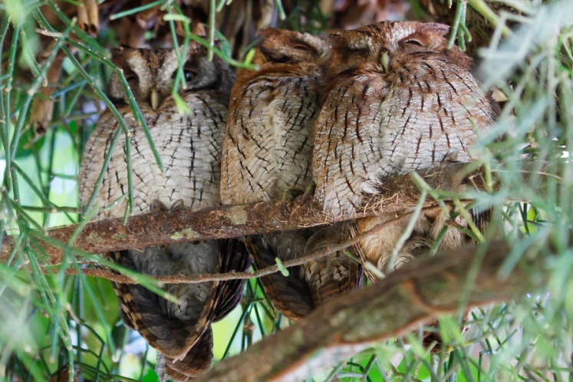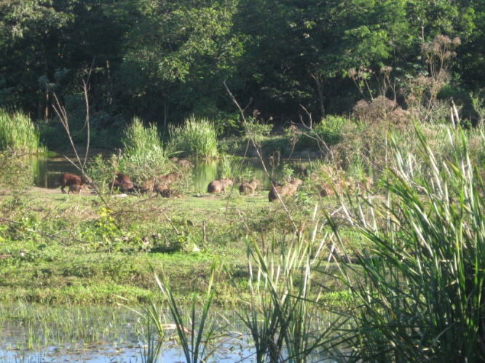
Three Tropical Screech Owls all in a row and Capybara on the Wetland Trail

The Wetland Trail was both picturesque and stuffed with birds. Returning to the lodge, watching flocks of egrets come in to roost and bats take flight, we felt exhilarated and exhausted in equal measure. Caiparinhas, a celebratory beer, a fabulously satisfying dinner and an early night were had by all. A fantastic first day in Brazil came to a close and we had so much more to look forward to.

Throughout the week we would rise early, have breakfast and then go out into the wilds of the reserve or beyond. The reserve trails were beautiful - The Waterfall Trail being a particular highlight. The eponymous waterfall was well worth the effort it took to reach it. The water is so pure and refreshing that Adilei preferred to scoop it up and drink it, rather than take some from a bottle. I was not so adventurous – it would have been just my luck if sipping this elixir resulted in a day spent running back and forth to the toilet, as my weedy, Western digestive system came to terms with some hitherto unknown nutrients and flora!
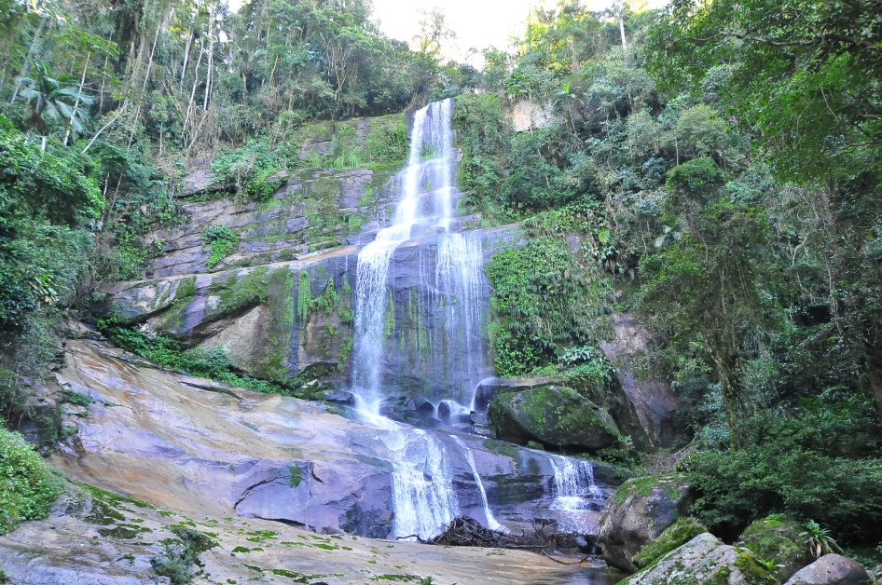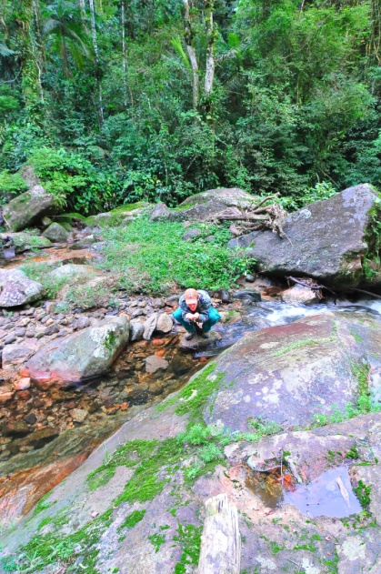
The Waterfall Trail with Adilei drinking his fill
We chose to visit the reserve in the Austral winter. This brought a couple of bonuses. It was drier and cooler than the summer and it was very quiet in terms of visitors. In fact, we pretty much got Adilei to ourselves for the week. Another bonus of this trip was we avoided areas with malarial mosquitoes. However, George and Jen did have a run-in with some Chiggers after an ill-advised roadside pit stop in some long grass! These horrible little parasites burrow into flesh and cause agonising itching.
Before we knew it, it was time to head to Rio airport for our flight to Cuiabá (pronounced key-a-ba), and the next leg of our adventure. REGUA had been incredible – the facilities, the birds, Adilei, and the habitat combining to make the whole week a magical and unforgettable one. We set off in buoyant mood, looking forward to whatever the second week might bring.
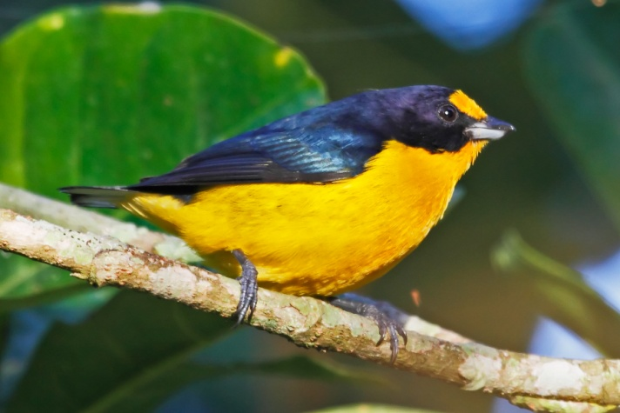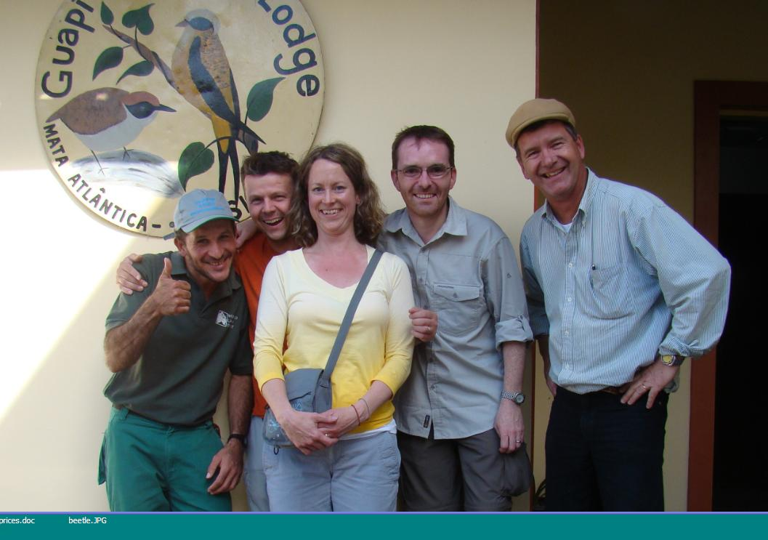
A Violaceous Euphonia and Saying goodbye to Adilei and Nicholas on the Lodge steps

The Pantanal and Chapada dos Guimarães
The room in Cuiabá was best described as adequate. We felt like the three bears with our three single beds in a row! The most difficult part was the noise - an incredible cacophony from road and nearby airport that continued relentlessly through the night and the wee small hours. When the alarm went off we were mostly already awake and dog tired.
After breakfast our guide for the week Bradley Davis, a Canadian now living in Brazil, arrived with our minibus and Brazilian driver Paolo. Bryce landed on-time, and after a quick bite of lunch, we hit the road.
Just outside the frontier town of Poconé tarmac transformed into compacted red dirt and rocks, signalling we were on the Transpantaneira Highway and finally entering the Pantanal proper. This road runs for 144km (89 miles) and features 126 hair-raising, single lane, wooden bridges. It stops at a dead end only halfway across the wilderness. However, it’s just as well it does, because if it completely bisected the Pantanal, it would alter the drainage patterns so dramatically it would destroy the entire ecosystem.
The Pantanal is a truly awe inspiring natural wonder, spanning a huge area where the borders of Bolivia, Brazil and Argentina meet - the majority being in Brazil. It teems with water birds, capybara, and caiman (South American crocodiles). It’s home to the world’s largest parrot, the hyacinth macaw, forest patches resonate with the calls of black howler monkeys - sounding for all the world like hugely amplified rumbling stomachs - and jaguars lurk in the shadows.
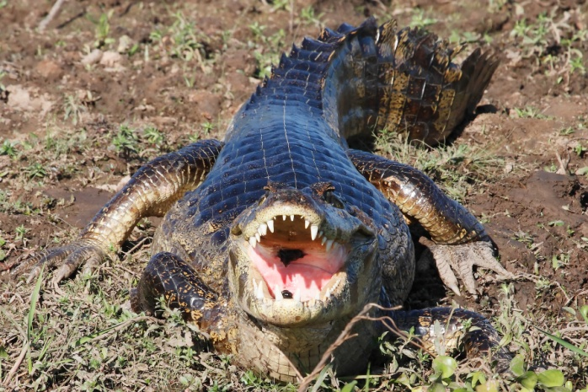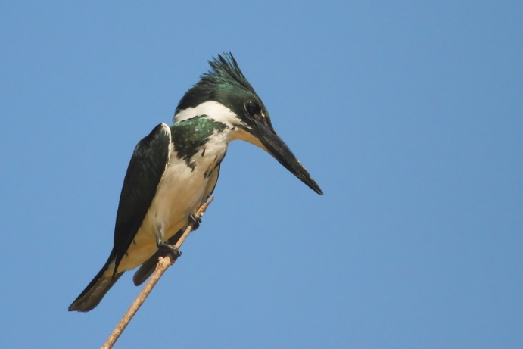
A Caiman and an Amazon Kingfisher
As with the previous week, we would rise early and make the most of every bit of daylight and even some of the night. Our accommodations were always good and the food excellent. The highlights were the three boat trips.
The first took us ashore via a boardwalk that led to a tower viewing platform. The tower seemed a bit rickety - the ladders up and down not for those inclined to vertigo, and the whole thing swayed when anyone moved - but it afforded fantastic views across the marsh. The marsh was full of birds and caiman while, up above, mixed flocks of vultures and storks circled effortlessly against a cobalt sky.
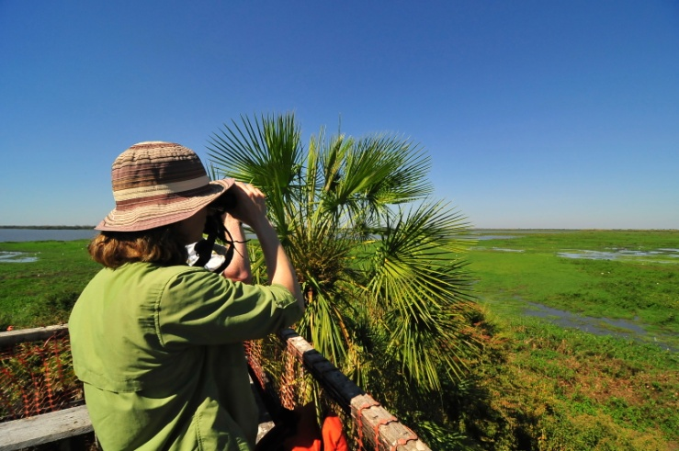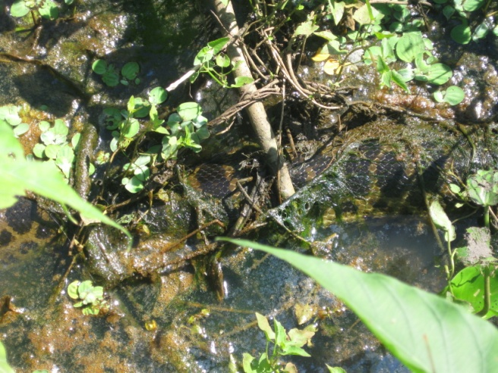
Jen on the viewing platform and a Yellow Anaconda hides in the weeds
The return leg across the boardwalk had to be curtailed at the first attempt to let a swarm of bees pass by. Never mess with a South American bee colony! With the coast clear, we resumed our crossing. The boatman pointed out a couple of Yellow Anacondas coiled and partially submerged in the water and vegetation.
After lunch and a brief rest, we headed made for the “official” entrance to the Pantanal - a cheesy tourist photo-opportunity moment but had to be done. The gate here is purely decoration, and isn’t actually at the start of the Transpantaneira. Some old blokes lift a wooden bar for you, and are officially supposed to work for the government checking fishing quotas and so on. However, Brad reckoned he’d never seen anyone stopped and searched in all the times he’d been past.
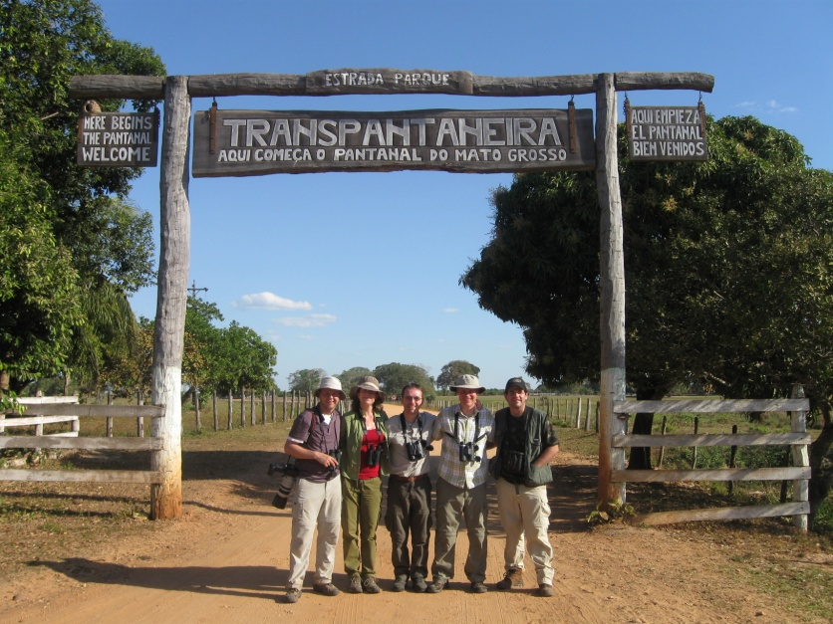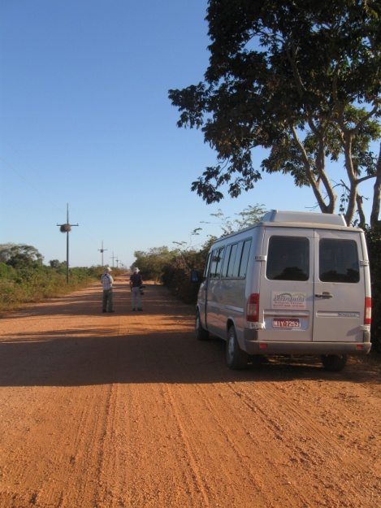
The official entrance to the Pantanal and our bus on the Transpantaneira Highway
The second boat trip came on the back of a hunch; Brad deciding we should try the Rio Claro (Clear River) for giant river otters. It turned out to be a good call.
The river was wide and claro and we all enjoyed the breeze as we buzzed along. Then it happened – a giant river otter shoved its head out of the water, eyeballed us and dived. These are truly giant otters by the way, with adults growing up to 2m in length! Further on, Brad told us that the boatman had trained a Black-collared Hawk to take fish from him. The boatman tossed a fish into the water and the hawk swooped down, grabbing it no more than ten feet from the boat!
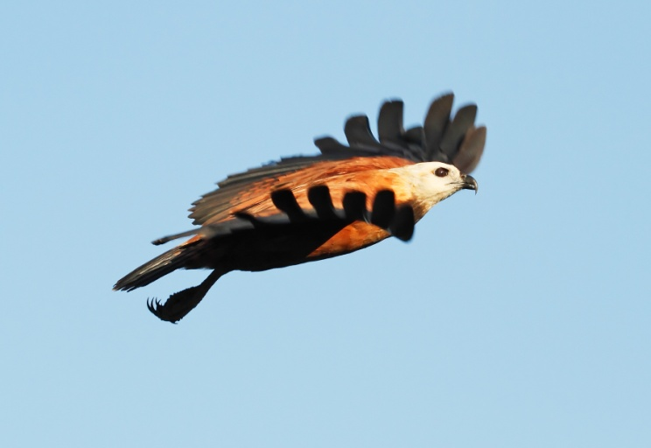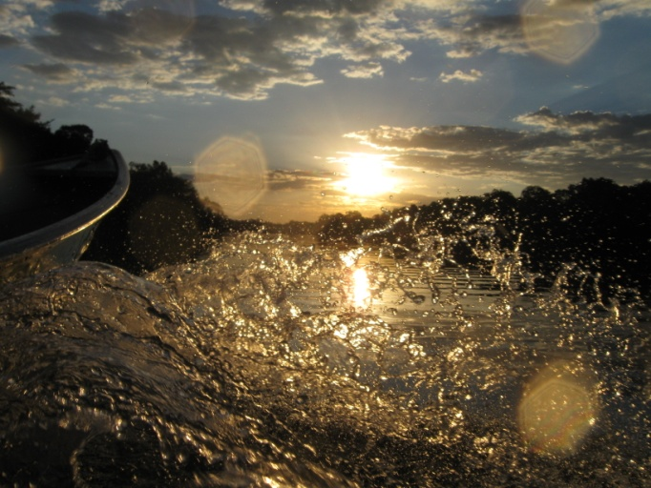Black-collared Hawk and sunset through the bow wake on the Rio Claro
The light on the return leg was beautiful as the sun began to set. George experimented with taking photos through the bow wake as egrets and cormorants came in to roost and a couple of bat-like, Band-tailed Nighthawks flitted back and forth above us. It had been an impromptu journey to remember.
Back on dry land and back in the minibus, we made for the Pantanal Wildlife Centre. With a fair amount of ground to cover, Paulo picked up the pace, giving us quite the ride through the darkness. At least he slowed down enough not to catch any air on the bridges! Soon enough, we made it safely to the entrance track to the PWC, slowed down, and turned on the spotlights. A female Brazilian Tapir and her calf stood momentarily then moved off out of range of the lights and into the darkness.
The third boat trip was on the Rio Pixaim, narrower than the Rio Claro, with more hyacinths along its edges. The same cool breeze was welcome in the heat. Impressive gatherings of caiman adorned small beaches on the shore and a family of seven giant river otters swam right up to and around the boat before heading off down river. Utterly incredible, but utterly incredibly, there was better to come!
Drifting quietly down the river, it narrowed and got shallower, all the time being choked by more and more hyacinths. At last, we got to the point where we could go no further, when Brad said he’d heard an Agami Heron. I’d wanted to see this bird more than any other. Brad gently purred an impression, and told us to stand up very carefully so as not to upset our boat. However, as George and Jen suddenly became very excited about the bird coming into view, Bryce and I panicked as we couldn’t see it!
Brad calmly backed the boat up, and BANG! The most exquisite bird I’ve ever seen - sitting on the bank, in full view, like a giant kingfisher. Apparently the locals call it the Hummingbird Heron – and for good reason. Shimmering, metallic blue, with silvery wisps down its deep rufous and blue striped neck, leading to the maroon belly – George grabbed a hasty couple of shots, before it took off and flew deep into the trees and out of view.
Feeling on top of the world, we headed back, not realising the amazing wildlife was not finished there. On this return journey, the otter family reappeared. This time they frolicked around the boat, occasionally taking fish from the boatman. A wildlife experience in a million.
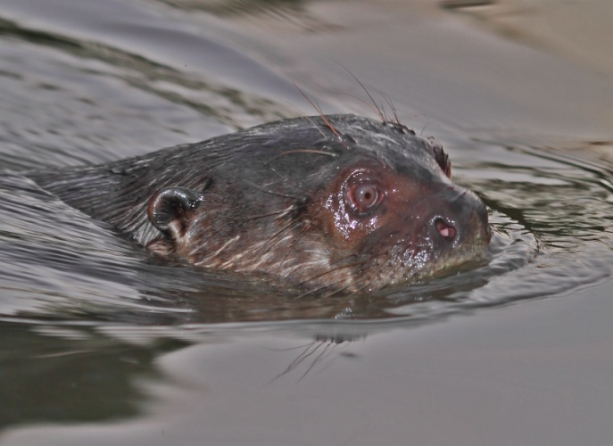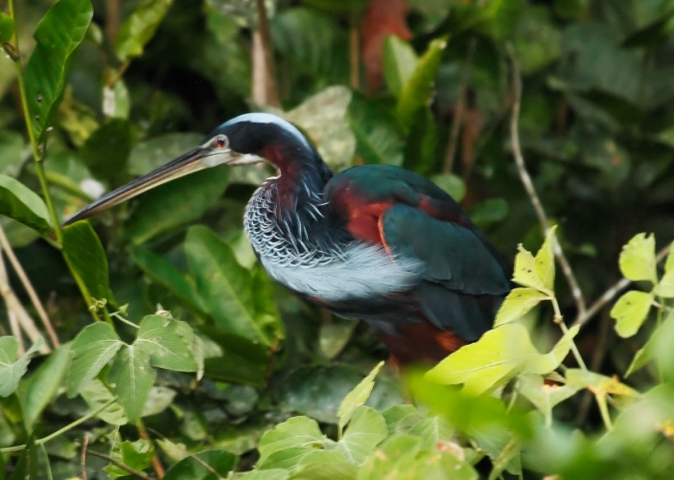
Giant River Otter and Agami Heron
On our last morning in the Pantanal, we returned to the gallery forest trail, energy levels dropping along with the temperature. The trail was quiet. However, we noticed something else had been on the path before us that morning. There in the sand, were the paw prints of a Jaguar! Even though we didn’t see the actual animal, we still got a vicarious thrill from thinking that we were walking in its footsteps.
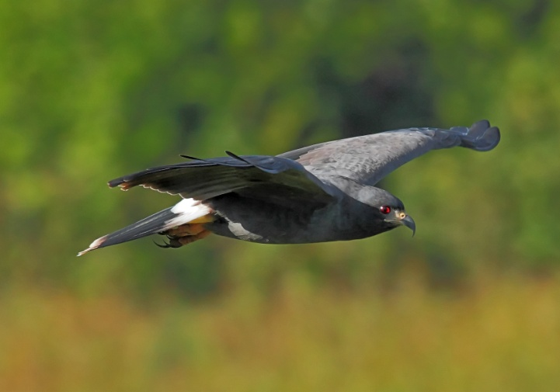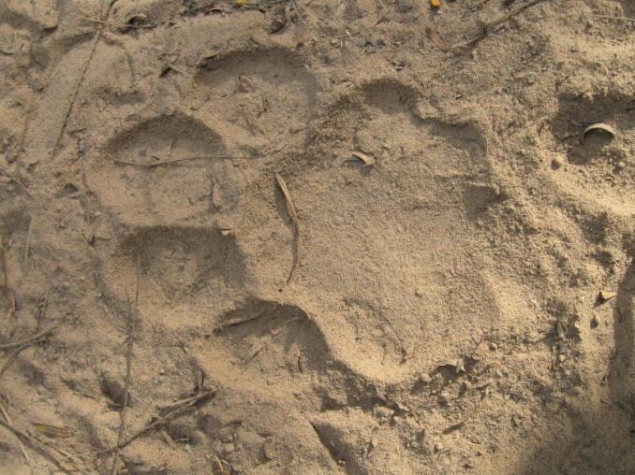
Jaguar footprints near the Pantanal Wildlife Centre and a Snail Kite
From here we drove to the Chapada dos Guimarães; a new habitat - dry savannah - and new wildlife delights. During the long journey all of us (apart from George) spent at least some time snoozing. Our hotel - The Pousada Do Parque - was lovely and after a very nice meal, we all had an early night.
The Agua Fria Road is a hot, dusty, red dirt track that stretches downhill, undulating for a few kilometres in a straight line. It doesn’t look much like prime birding habitat, but it’s well known for the specialty birds of the Cerrado - a dry scrubland habitat of central Brazil. July, at the peak of the dry season, isn’t the best time to visit the Cerrado, but we thought we’d give it a go anyway. Wandering down this dusty road, we had to constantly move in to the side to let the locals career past in their VW camper vans.
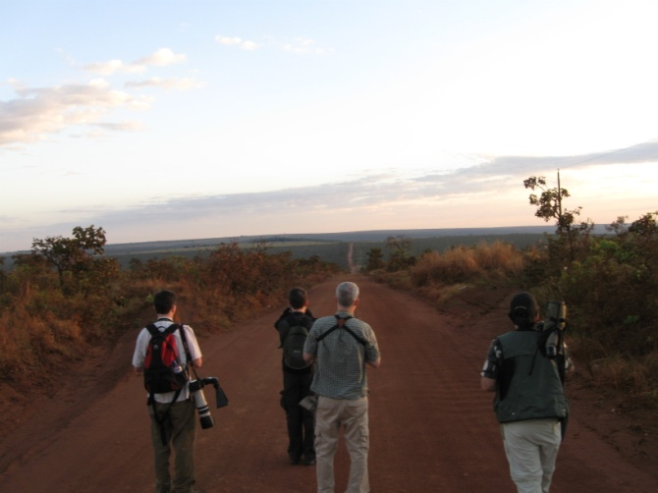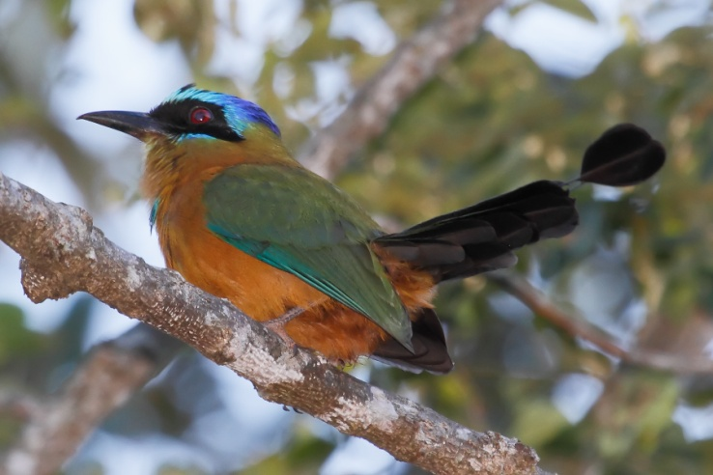
The Agua Fria Road and Blue-crowned Motmot in the gallery Forest

After lunch and an afternoon spent birding in gallery forest, we returned via the outlook that claims to be at the Geodesic centre of South America. The view was fantastic and we could see a gigantic fire as it raged across the valley floor. Fortunately, fire is a natural and necessary part of the cycle of life in this part of Brazil.
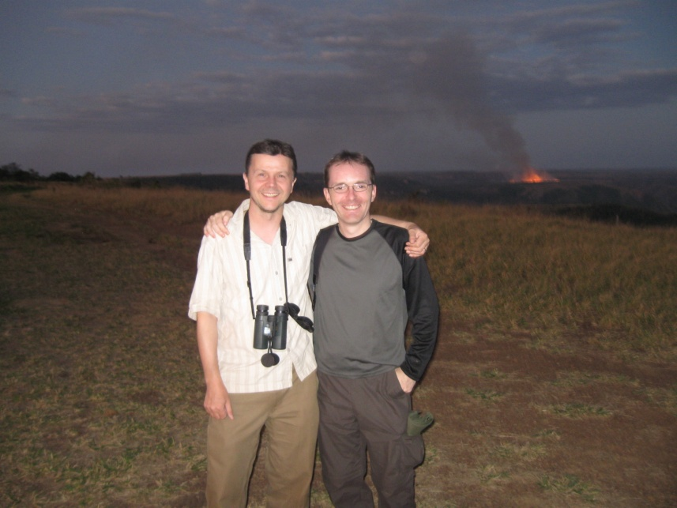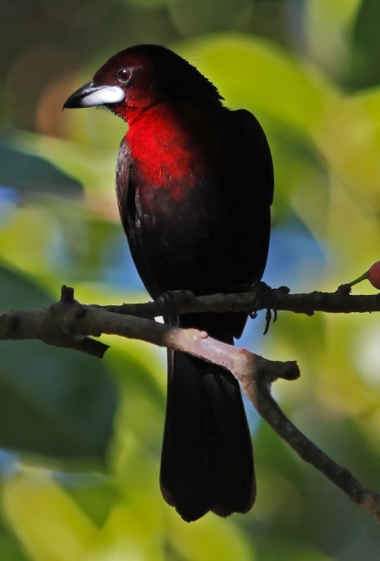
Pete and George at the Geodesic Centre and a Silver-beaked Tanager

After dinner, we did some night birding along the entrance track to the Pousada. We rounded off the night chasing down a Tropical Screech Owl, our patience and stamina rewarded when it landed within a few feet – regarding us scornfully with fierce little eyes. Another brilliant day came to an end. We crashed into bed and prepared for the reality that tomorrow was our last in Brazil!
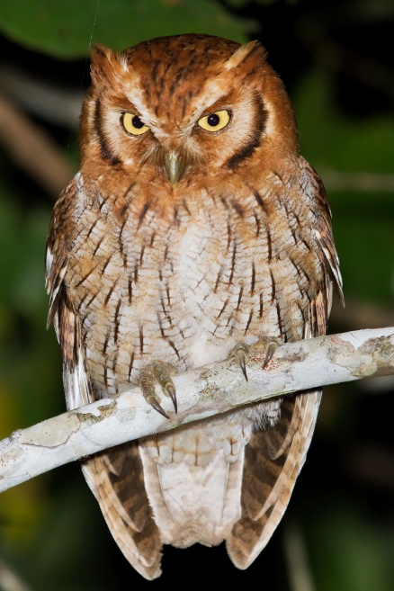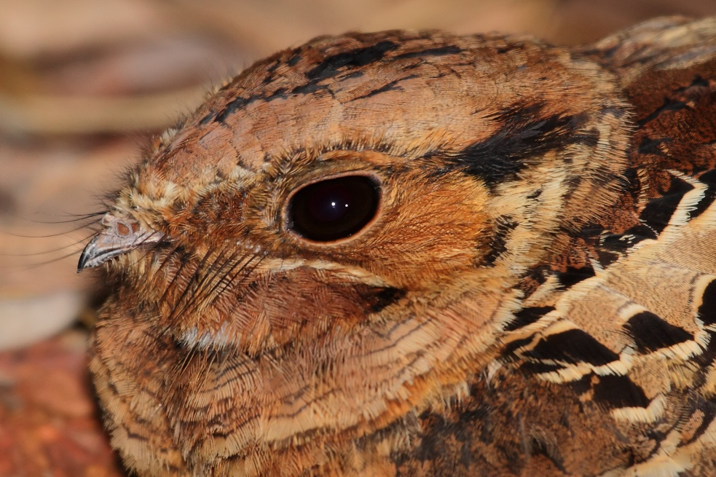
Tropical Screech Owl and a Pauraque

Two weeks had flown past in a whirlwind of wildlife, laughs and excitement. We were ready for one last push and maybe one last special bird?
After some intense early morning birding, we visited a local tourist attraction – The Bridal Veil Falls. Walking down the path, feeling the heat of the day start to rise, we came to the view-point overlooking the falls, and that last special bird appeared. A pair of magnificent Red-and-green Macaws flew in tandem down the valley and gave George the chance to take an amazing photo.

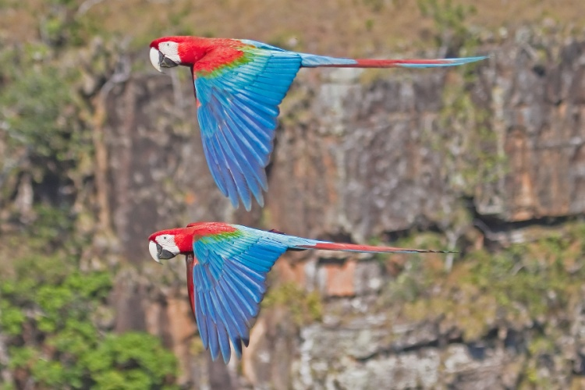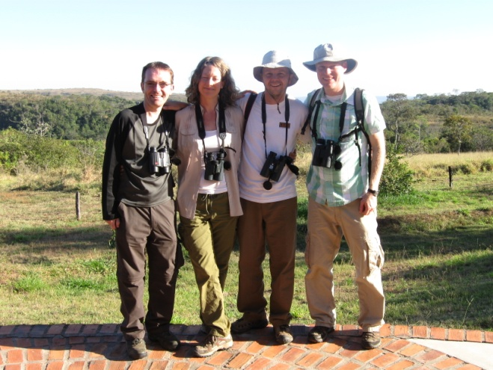
A pair of Red-and-Green Macaws and the gang say farewell to Brazil

We left to fly home – elated, thrilled and thoroughly satisfied by what had been the most incredible birding experience we’d ever had.

