Ecuador – Land in the Sky
The world is a small place for those of us lucky enough to have time, money and a sense of adventure. There are few places one cannot reach in a matter of hours by plane. Trips that in days of yore would have taken many weeks or even months to complete can be undertaken in a week. With all of these advantages in my favour, and a very efficient friend in charge of organisation, I set off for Ecuador in the north-west corner of South America at the beginning of February 2012.
I have to point out that the whole purpose of the trip was to see as many bird species as possible. I am a keen birder - and so were my companions. Therefore, writing a blog for the general reader or traveller that is not so keen on birds has presented me with a bit of a challenge. I hope I don’t bore the pants off you!
I flew from Glasgow to Amsterdam, then on to Panama City, before landing in Quito (the capital city of Ecuador) at around 11.30pm local time, only half an hour behind schedule. After flying for twenty-three hours, I was very glad to see my friends George and Jen already safely arrived from the US. We got straight in a taxi and high-tailed it to our hotel. This was to be our first taste of Ecuadorian driving but more of that anon.
The hotel was pleasant and comfortable. We had a triple room for the first night to save money but there was plenty of space. George and Jen are married, so I became their ‘kid’ for the evening! Exhausted, I hit the pillow and made my way to the land of nod almost instantly. However, the citizens of Quito are very fond of their car horns and like to toot them incessantly. There are also a LOT of cars on the road. The noise was cacophonous and we all had a bit of a fitful night overall.
The next day dawned with cloudy skies but no rain. At 2,800m (9,200ft) Quito is the second highest capital city in the world. The air is thin and we could all feel it. Today, we were going to explore the city, get our eye in as far as the birds were concerned, and wait for our friend Bryce to arrive from the US later that evening.
After breakfast, we set out by taxi for the Botanic Gardens. If we thought night-time driving was disconcerting, then day-time was even more so. It would appear that red lights are optional, lanes are marked to use up some spare paint and pedestrians are fair game. You really need to keep your eyes covered while a passenger and wide open if you are walking around!
The city sprawls out along the Guayllabamba river basin, in the shadow of the Pinchincha volcano, on the Eastern slope of the Andes. It is the usual chaotic and eclectic hotch-potch of buildings and streets that are typical of most South American cities. It is a pretty safe place in the day but you need to be careful where you go at night. Our trip to the Botanic Gardens was very enjoyable, with a couple of new bird species seen. We wandered breathlessly (and carefully!) through the streets, uphill towards the Municipal Park, and spent a relaxing afternoon watching a few birds and enjoying the views across the city.
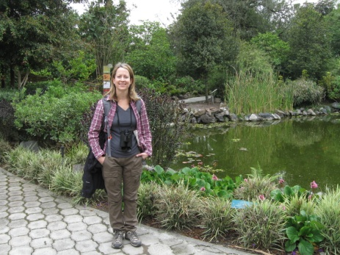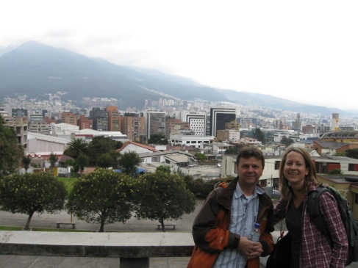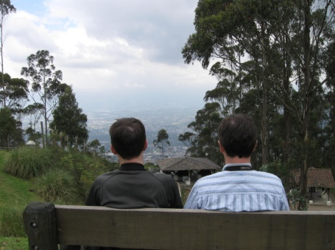
(l-r botanic gardens, view across Quito, Municipal Park where two backs of heads are better than one!)
That evening Bryce arrived, we split into two rooms, and prepared for the main event - the cloud forest and the birds.
Ecuador is the most bio-diverse country in the world by land mass. It boasts over 1600 species of birds and as such is a birder’s paradise. Parrots, hummingbirds, tanagers, and many others abound. Some are so impossibly colourful that they look like they got trapped in a nursery and were daubed relentlessly and randomly by the kids’ paintbrushes. We met our guide for the week at 5am and jumped in our minibus to drive out of the city and into the countryside. Hunting birds - but without guns.

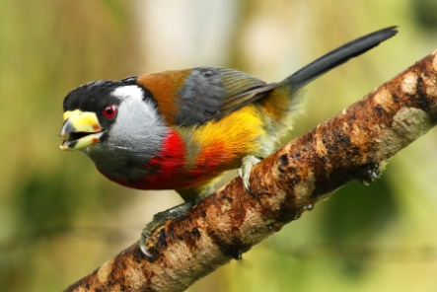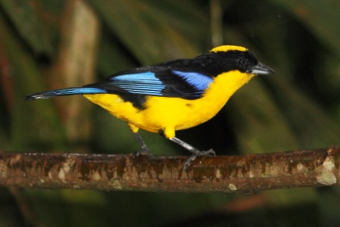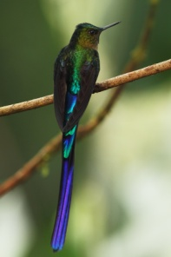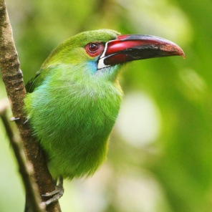
(l-r Toucan Barbet, Blue-winged Mountain Tanager, Violet-tailed Sylph, Crimson-rumped Toucanet)
Our base for the week was the world famous Tandayapa Bird Lodge. It is host to one of the bird spectacles of the world. Just click on the link to witness a small taste of the hummingbird feeders. When we arrived late in the evening the feeding frenzy was in full flow. We saw twelve different species within a matter of minutes and the number of birds was in the hundreds. Hummingbirds are not just stunning little birds, they have some of the best names of any birds: Gorgeted Sunangel, Sparkling Violet-ear, Empress Brilliant, Green-crowned Woodnymph, and Shining Sunbeam are just some examples.
There were three other main avian highlights of the trip.
We travelled to a farm near Chontal to see Oilbirds. These strange birds are the only ones to use echo-location similar to that used by bats and the only fruit-eating nocturnal birds. They roost in caves or crevasses by day. The name derives from the fact that they eat oil palm fruits. The adults feed these to the chicks, which sit on ledges getting incredibly fat in the process. Rather gruesomely, the chicks are harvested by some indigenous peoples and boiled down to extract the oil.
To reach this particular colony, we had to get harnessed and roped up, descend three sets of 10m high bamboo ladders down through a crevasse, to see the birds on the ledges. One of the ladders was being swamped by a waterfall. We got soaked, but it made us all feel like Indiana Jones. We only saw three birds but they were well worth the effort.
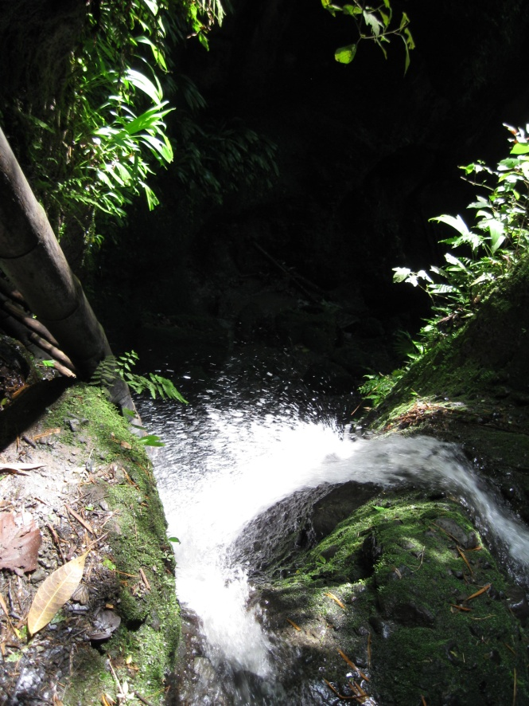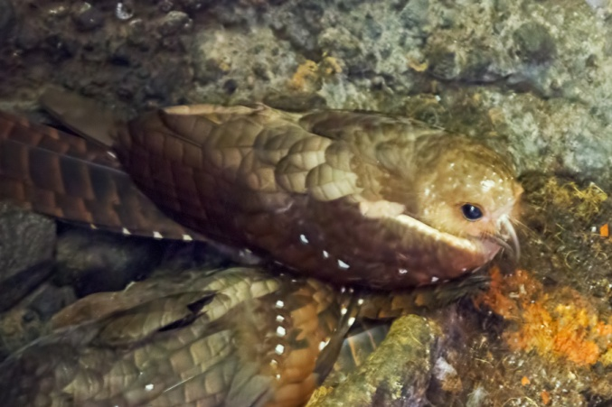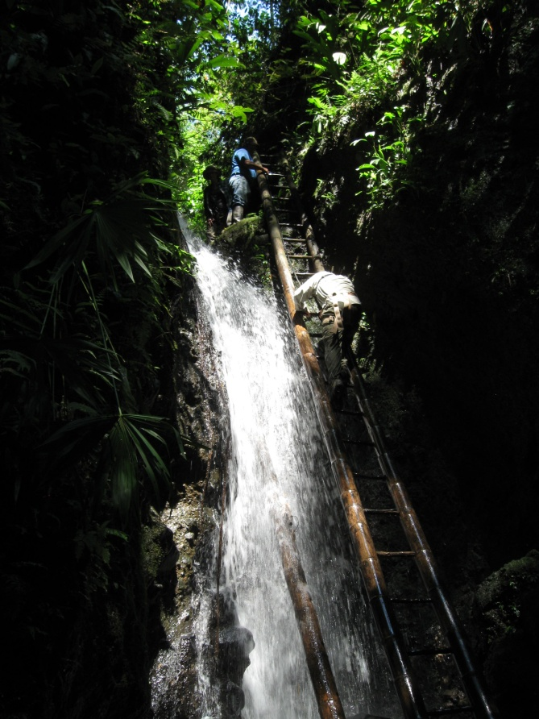
(l-r Chontal Gorge, Oilbird roosting, braving the ladders and the falls)
The second highlight was a visit to Refugio Paz or Paz de las Aves. A place where men whispered to birds and near-mythical Antpittas could be called by name out into full view. At least, that was what we had read. The Refugio Paz is run by a couple of brothers - Angel and Rodrigo Paz. They are farmers but now run an eco-tourism business based around the special birds they discovered breeding on their property. Angel in particular has built up a special rapport with some species that are normally very difficult to see, feeding many of them by hand and habituating them to human contact.

As we walked Angel was whistling the call of various Antpittas and calling their names. It was more than a little surreal to be following a man in gum boots down a muddy forest trail, as he called out the name “Susan!” in a heavy Spanish accent! Unfortunately, she was not responding and neither was Maria the famed Giant Antpitta which started the whole thing off. We waited patiently on the trail as Angel tried to summon Shakira the Ochre-breasted Antpitta! Yes, ‘she’ really is named after the Colombian pop star; on account of shaking ‘her ‘booty in a similar fashion. Normally, Shakira is the least regular and reliable of the pittas seen at Paz de las Aves but, for some reason - possibly the extra rainy weather this season - she was the only one we saw! A lovely little thing, she sat and watched us but never really took any of the worms on offer.

The last highlight involved a trip to the mighty Antisana volcano. This behemoth rises to 5,700m (18,700ft) and is home to the world’s heaviest flying bird - the Andean Condor. We saw a few of these incredible birds but the best was an adult sitting by the roadside that flew off very close to us. It is difficult to describe how impressive this bird is close up. It is MASSIVE. The wingspan is more than 10ft and each wing looks big enough to seat a family of four for dinner.

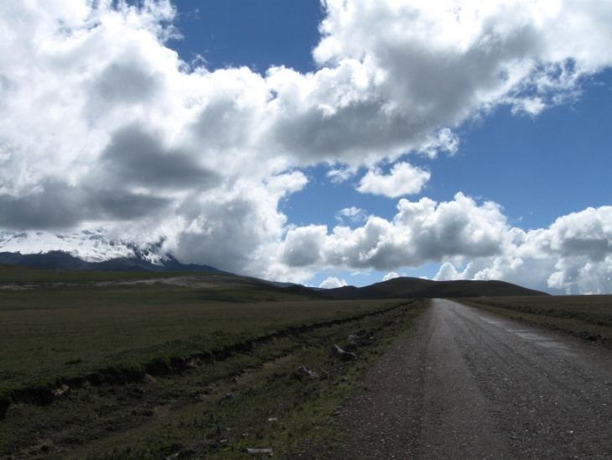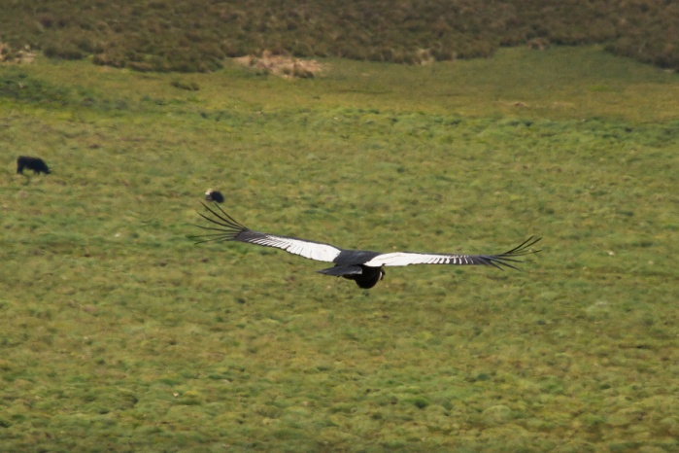

(l-r Antisana volcano shrouded in cloud, a magnificent Andean Condor)

We did in fact do a few typically touristy things. The first was to eat empanadas on the street in a small town. Cooked in front of us by a roadside vendor, they were tasty but not particularly healthy! The second thing was to visit Mitad Del Mundo (Middle of the Earth). This is where the equator passes through the country and it has a museum, monument and host of tacky tourist shops to help you enjoy it! It was a daft bit of fun as we returned to Quito and one afternoon. We also went out to the Old Town and had dinner on a couple of evenings. This is a very safe area of the city, dominated by colonial architecture and a very grand cathedral.

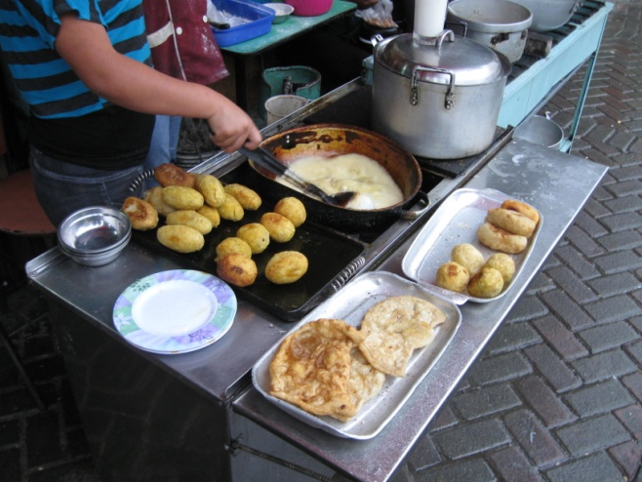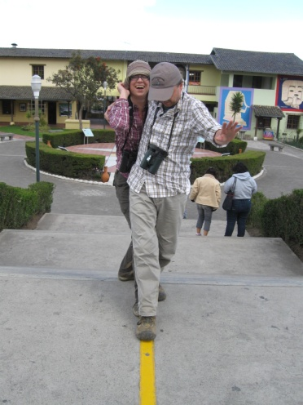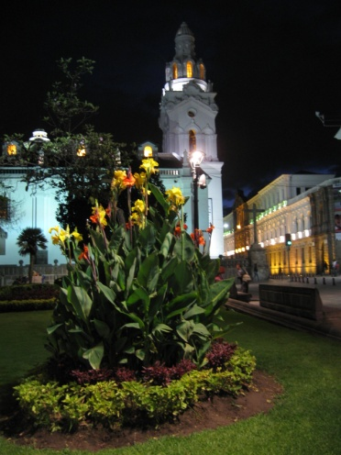

(l-r empanadas in the street, Mitad Del Mundo, Quito Old Town at night)

This was my second trip to South America. Previously, our little band of explorers spent two weeks birding in Brazil. In comparison, I found the food in Ecuador a little dull. Most meals involve the liberal addition of coriander (not my all-time fave herb). It was all fairly edible but nothing really stood out as delicious. There was no need for malaria tablets or injections as the Anopheles mosquito cannot survive at the altitudes we visited and I was only bitten once by an insect, which was a real bonus in a tropical country. The people were friendly and easy-going, and service was mostly excellent. The weather was mostly cloudy, damp and changeable. We did have a couple of hot days at lower elevations but nothing unbearable or oppressive. The scenery was mostly mountainous, lush and forested in the areas we visited.

All in all, I enjoyed Ecuador. In terms of birds it was extraordinary. I saw over 300 species in a week and 278 of those were ones I’d never seen before! If you were not visiting for the birds, I’m not convinced it would be an obvious first choice in terms of visiting South America. Brazil, Peru or Argentina would undoubtedly hold more appeal to the average traveller. However, if you are interested, there are a few links here to discover more or investigate a trip.

I hope you enjoyed the blog and if you do end up in Ecuador, have a great time, but watch out for the cars!

Links:
Tropical Birding - our tour organisers and guides for the week.
Tandayapa Bird Lodge - where we were based and a very comfortable place to stay in the heart of the jungle.
Peter Carroll - the author of the blog and also an author of novels!
George Scott - the photographer of the birds featured in this article. More great shots are to be found on his website.

