Portugal - Beaches, Birds and Piri Piri
For the past few years our family has taken a break together in October. Usually, we’ve plumped for somewhere in the UK, with the Isle of Mull and Northumberland being previously favoured destinations. However, this year, we decided to venture further afield and try Portugal. It turned out to be a good choice.
On Sunday 13th, my wife Sharon, daughter Megan, Dad Mick and I flew out from Manchester, arriving at Faro airport around 8.30 in the evening. It was already dark by the time we picked up our hire car and set off for our villa in the small town of Sesmarias. After missing a vital exit on the motorway, we spent a frustrating couple of hours on the road before reaching our accommodation and crashing into bed exhausted.
Next morning, we got up late and decided to go on a leisurely explore of some nearby towns and maybe a beach or two. After a short stroll along the promenade at Portimao, we stopped off in the small town of Ferragudo for some lunch. The sun shone, fishermen repaired their nets on the harbour side, gulls wheeled, the waitress was very friendly, and we began to unwind. We dropped into the nearest beach to our villa at Carvoeiro and had a wee paddle. As the sun went down, we returned to the villa and wandered up the street to have a pizza.
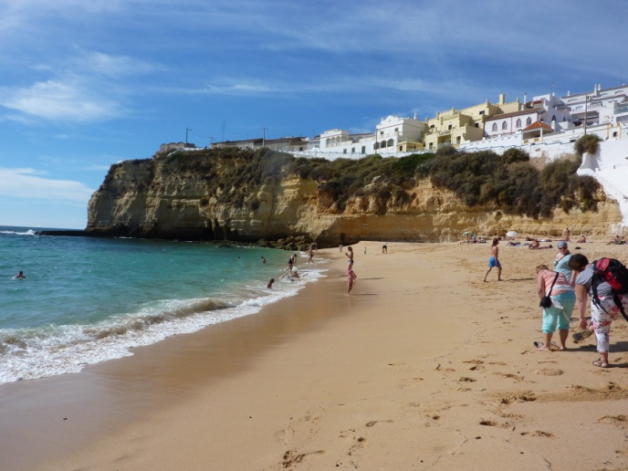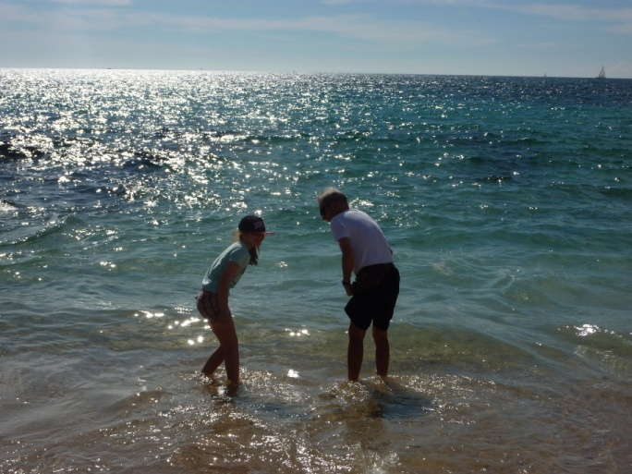

On Tuesday, we headed for the most south-westerly point on the European mainland - Cabo Sao Vicente. First stop on the way was one of the beaches at Sagres - famous for its beer. The beach was spectacular, with a huge Atlantic swell attracting a crowd of swimmers and surfers. As we finished a coffee in a beachside cafe, Sharon spotted a large bird and pointed it out to me: a short-toed eagle. Over the next few minutes, we watched as three or four of these magnificent raptors, along with a couple of booted eagles and a black kite, moved overhead. This area is one of the best in Europe for observing raptor migration and it was living up to its reputation.
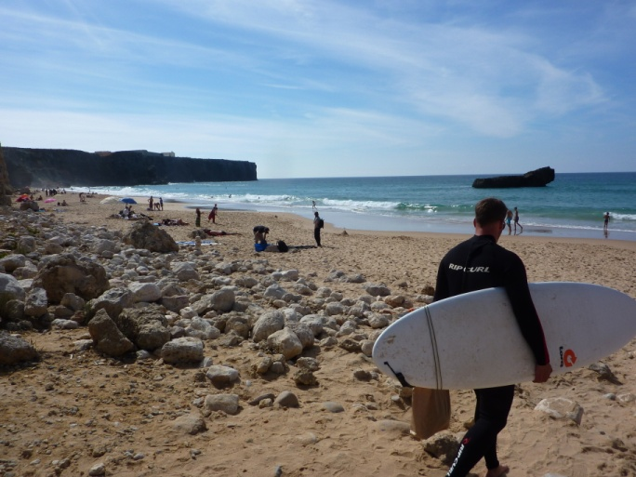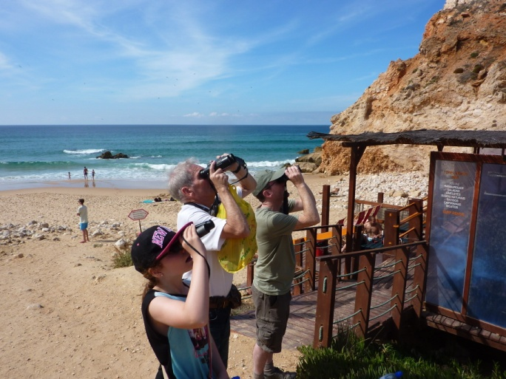
The headland at Cabo Sao Vicente was surprisingly close by and took less time to reach than we’d thought it might. A collection of roadside stalls offered tourist knick knacks, clothing and jewellery and the girls spent a bit of time browsing as me and Dad tracked down thekla larks in the adjacent scrubland. We stopped off at Martinhall on the way back where Megan rolled down the dunes.
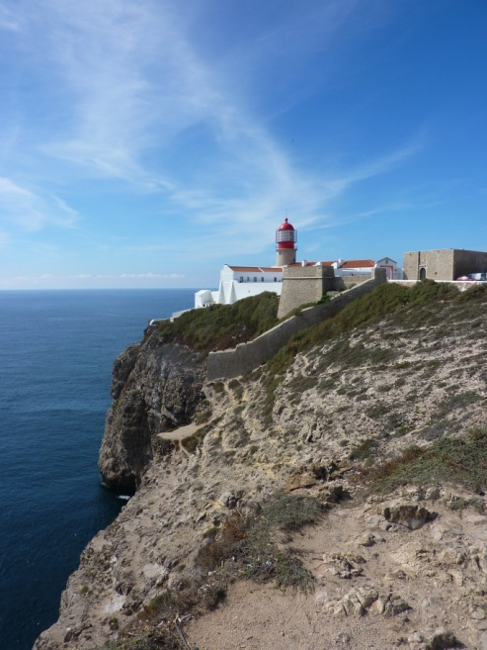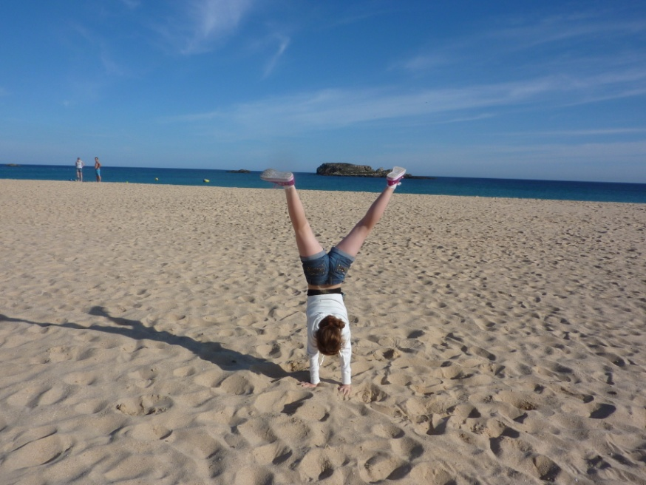
Wednesday saw me and Dad up early to visit the wetland at Lagoa dos Salgados while the girls had a lie in and lounged about the pool. We saw a few hoopoes, a fishing kingfisher, a flock of white storks, a purple gallinule and a couple of scruffy, juvenile flamingos. That afternoon my sister, Louise, and her husband, Kenny joined us - they’d spent the preceding few days in Lisbon and Evora.
Thursday morning saw Mick and Kenny off to play golf, so the girls and I headed for the mountainous interior. We took a leisurely stroll up through the town of Monchique to a cork oak plantation before returning to the town square for lunch. The sun blazed down as we wound upwards to the highest point in the Algarve - the mountain-top at Foia. The views were spectacular. On the way back we stopped at the roadside to admire a large flock of white storks and a smaller flock of leggy flamingos. Re-united with the golfers, we had dinner in Carvoeiro.
Friday was cooler and cloudier than the previous few days had been. Me and Dad decided to try our luck up at Foia and see if we could find a couple of birds that would be new to us - rock bunting and Bonelli’s eagle. The others decided to have another lazy morning by the pool. We reached Foia to find it shrouded in cloud and although we did get rock bunting, the eagle evaded us. That evening we headed back to Ferragudo and had dinner at a small restaurant called Toc Toc - superb Portuguese cuisine and the owners were lovely people.
Saturday was our last full day, although Louise and Kenny would be staying on for a few more further up the coast. Mick and Kenny had another round of golf while the girls and I headed back out to the Cabo Sao Vicente area for beach fun and a bit more birding. We re-convened at Praias dos Caneiros - a spectacular beach not far from our villa. We played games on the beach before indulging in a top notch meal as the sun set over the sea.
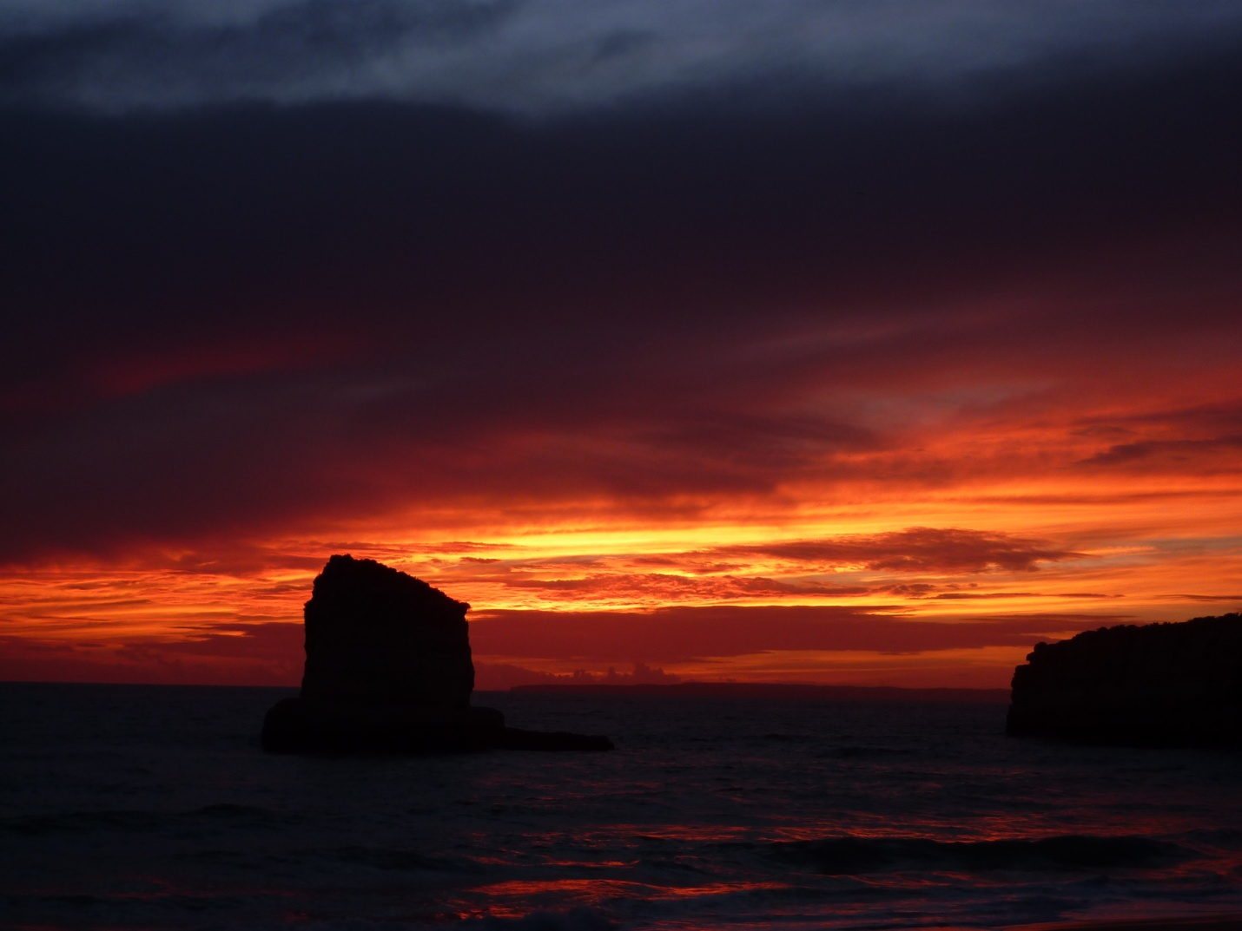
Sunday saw the original quartet return home. The flight was uneventful and making good time, until we reached Manchester. As we descended, we began to be buffeted by turbulence and the captain went into a holding pattern for a bit. Then, he aborted his next attempt at landing, surging upwards and causing a heady mixture of consternation and hilarity. Eventually, after the cloudburst passed, we landed without further incident and tackled the long drive home to Scotland.
I’ve never visited Portugal before and was really taken by it. The people are super-friendly, impressively multilingual, and take an approach to customer service I’ve rarely seen bettered. The beaches are pristine, the weather was beautiful, the traditional food great, and the scenery superb. If you’re a birder, then it’s also excellent - without trying too hard, I saw over 80 species, with five of them being new to me. I reckon we’ll be back.
